# Name: Apurba Koirala

# Reg no: 22BCE3799

# Subject Code: BCSE302P

# Course Title: Database Systems

# Lab Slot: L33 + L34

# Guided by: Dr. Shashank Mouli Satapathy

**Exercise - 1**

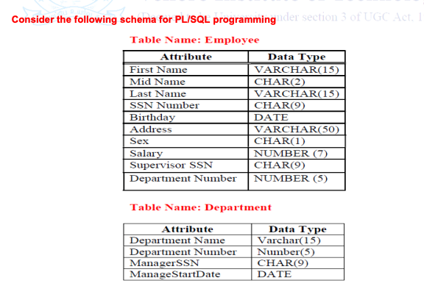

Constructing Schema :

1.

Code:

DECLARE v_empno NUMBER := 2; v_salary NUMBER; BEGIN

SELECT salary INTO v_salary

FROM Employee

WHERE empno = v_empno;

DBMS_OUTPUT.PUT_LINE('Salary: $' || v_salary);

EXCEPTION

WHEN NO_DATA_FOUND THEN

DBMS_OUTPUT.PUT_LINE('Employee not found.');

END;

Output:

2.

Code:

DECLARE v_empno NUMBER := 3;

BEGIN

DELETE FROM Employee

WHERE empno = v_empno;

IF SQL%ROWCOUNT > 0 THEN

DBMS_OUTPUT.PUT_LINE('Employee deleted successfully.');

ELSE

DBMS_OUTPUT.PUT_LINE('Employee not found.');

END IF;

END;

/

Output:

3.

Code:

DECLARE

v_current_date DATE := SYSDATE;

BEGIN

DELETE FROM Employee

WHERE months_between(v_current_date, birthday) / 12 > 60;

DBMS_OUTPUT.PUT_LINE('Employees with age >60 deleted successfully.');

END;

/

4.

Code:

BEGIN

FOR emp_rec IN (SELECT *

FROM Employee

WHERE salary < 1000)

LOOP

DBMS_OUTPUT.PUT_LINE('Employee: ' || emp_rec.first_name || ' ' || emp_rec.last_name);

END LOOP;

END;

/

Output:

5.

Code:

BEGIN

DELETE FROM Employee

WHERE salary < 2000;

DBMS_OUTPUT.PUT_LINE('Records deleted successfully.');

END;

/

Output:

**Exercise – 2**

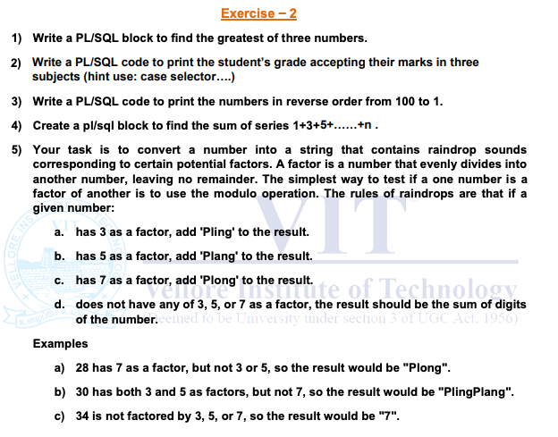

1.

Code:

DECLARE num1 NUMBER := 10; num2 NUMBER := 5; num3 NUMBER := 8; greatest NUMBER;

BEGIN

IF num1 >= num2 AND num1 >= num3 THEN greatest := num1;

ELSIF num2 >= num1 AND num2 >= num3 THEN greatest := num2; ELSE greatest := num3;

END IF;

DBMS_OUTPUT.PUT_LINE('The greatest number is: ' || greatest);

END;

/

Output:

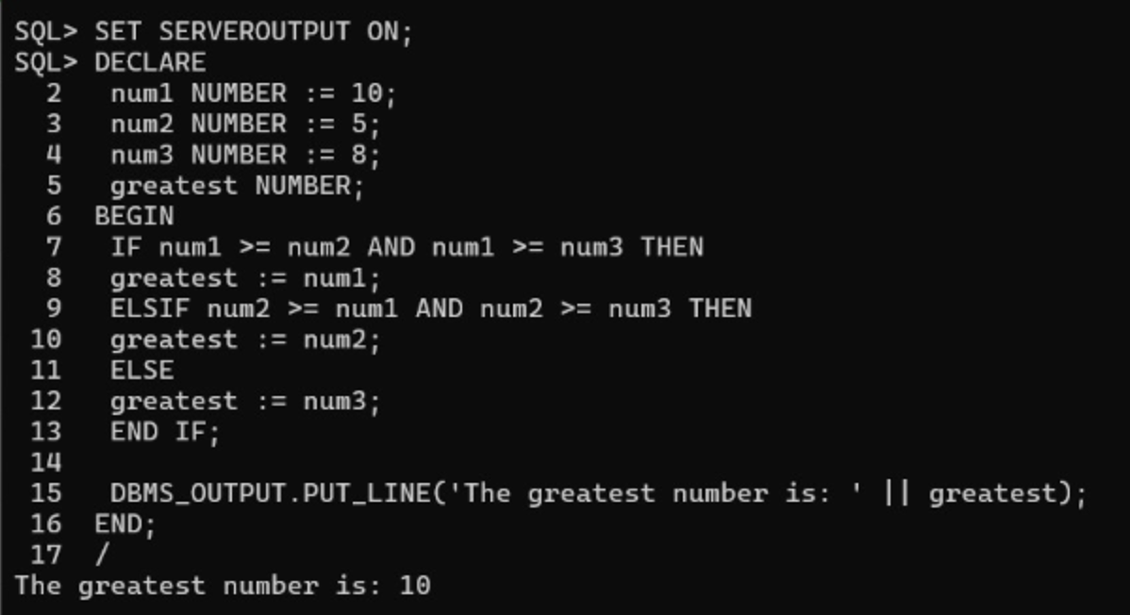

2.

Code:

DECLARE marks1 NUMBER := 80; marks2 NUMBER := 75; marks3 NUMBER := 90; average NUMBER; grade VARCHAR2(2); BEGIN

average := (marks1 + marks2 + marks3) / 3;

CASE

WHEN average >= 90 THEN grade := 'A';

WHEN average >= 80 THEN grade := 'B';

WHEN average >= 70 THEN grade := 'C';

WHEN average >= 60 THEN grade := 'D';

ELSE grade := 'F';

END CASE;

DBMS_OUTPUT.PUT_LINE('The student''s grade is: ' || grade);

END;

/

Output:

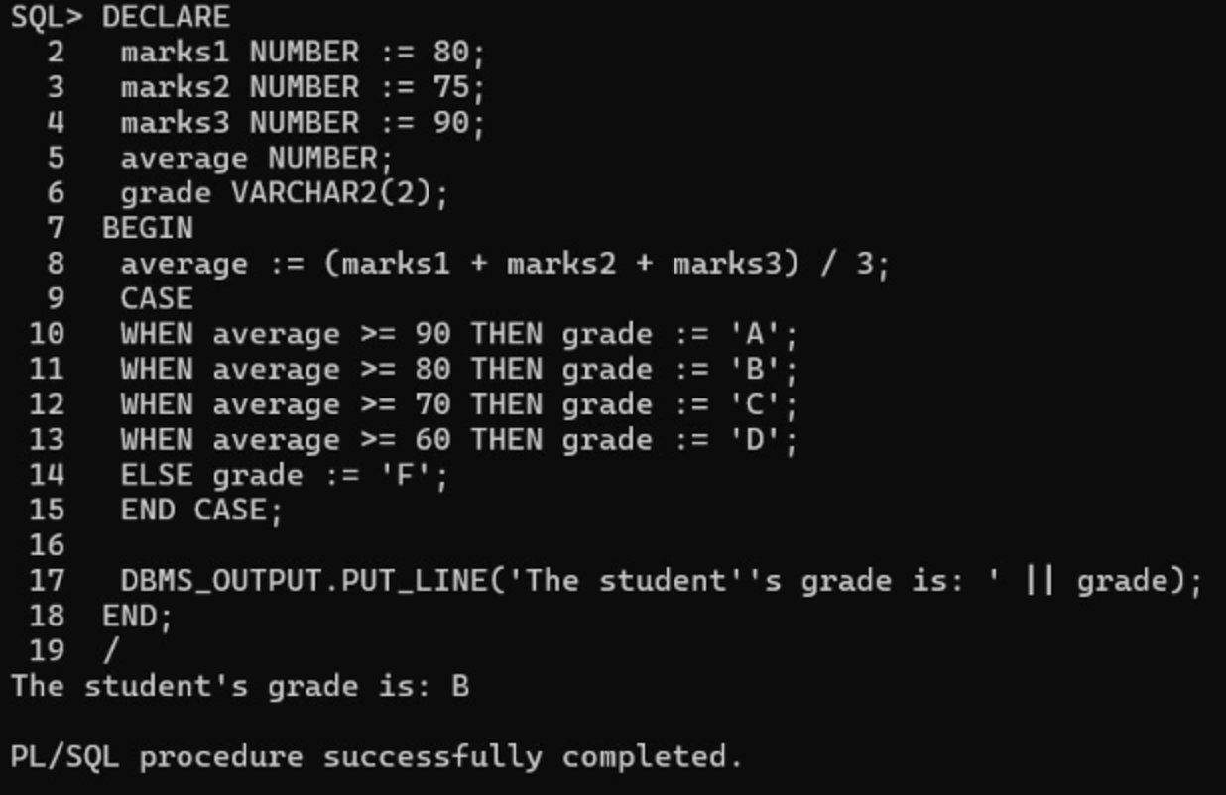

3.

Code:

DECLARE

counter NUMBER := 100;

BEGIN

WHILE counter >= 1 LOOP

DBMS_OUTPUT.PUT_LINE(counter); counter := counter - 1;

END LOOP;

END;

/



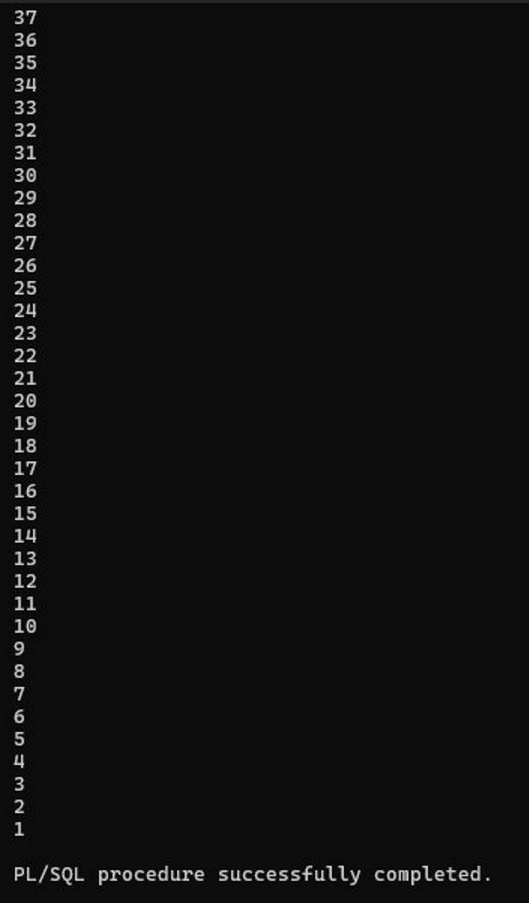

4.

Code:

DECLARE

n NUMBER := 40; sum_odd NUMBER := 0; num NUMBER := 1; BEGIN

WHILE num <= n LOOP sum_odd := sum_odd + num; num := num + 2;

END LOOP;

DBMS_OUTPUT.PUT_LINE('Sum: ' || sum_odd);

END;

/

Output:

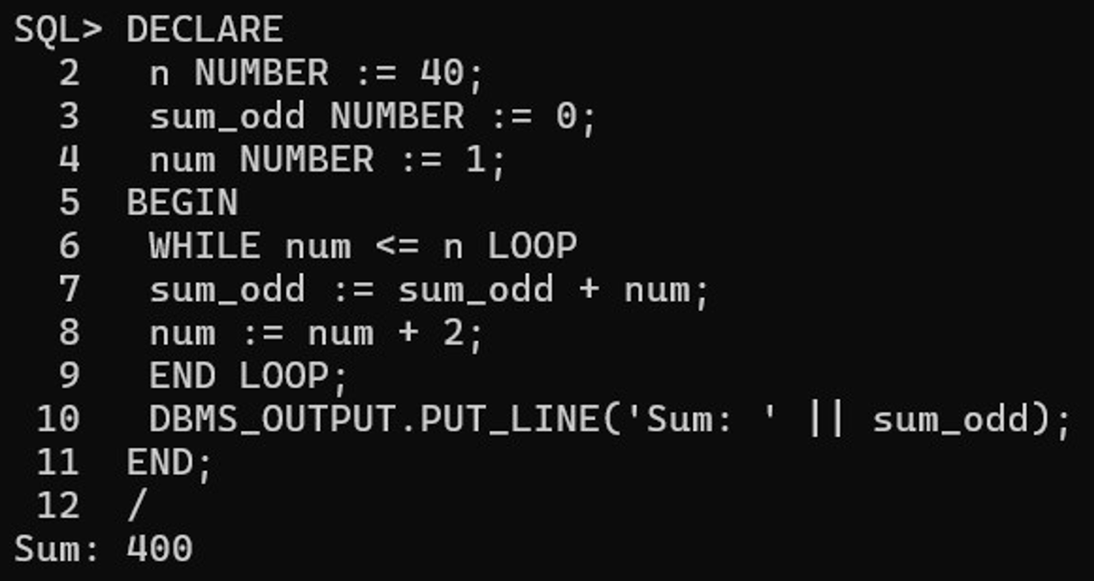

5.

Code:

DECLARE number_to_convert NUMBER := 28; result VARCHAR2(100) := '';

BEGIN

IF MOD(number_to_convert, 3) = 0 THEN

result := result || 'Pling';

END IF;

IF MOD(number_to_convert, 5) = 0 THEN

result := result || 'Plang';

END IF;

IF MOD(number_to_convert, 7) = 0 THEN

result := result || 'Plong';

END IF;

IF result = '' THEN

result := TO_CHAR(number_to_convert);

END IF;

DBMS_OUTPUT.PUT_LINE('The converted string is: ' || result);

END;

/

Output:

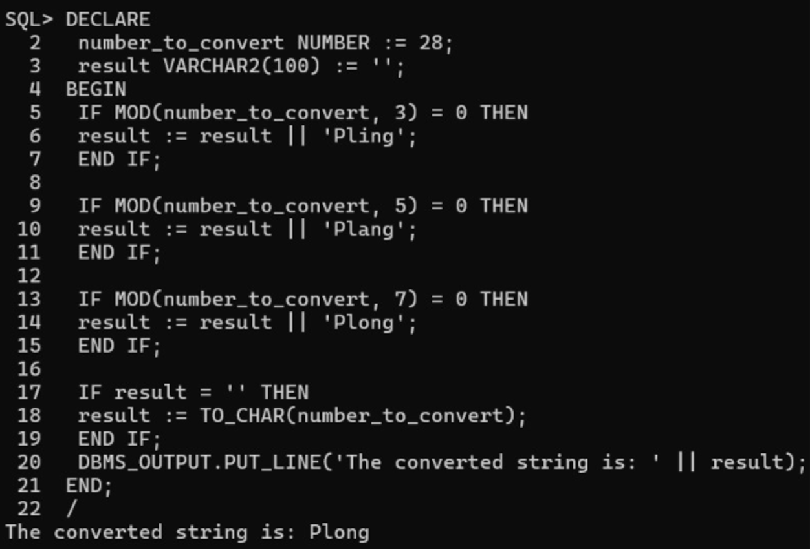

**Exercise – 3**

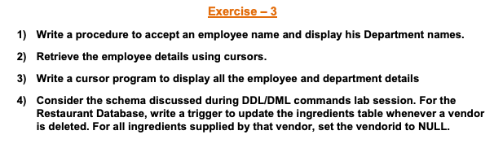

1.

Code:

CREATE OR REPLACE PROCEDURE GetEmployeeDepartments ( p_first_name IN Employee.first_name%TYPE, p_last_name IN Employee.last_name%TYPE

)

IS

BEGIN

FOR dept_rec IN (

SELECT d.department_name

FROM Employee e

JOIN Department d ON e.department_number = d.department_number

WHERE e.first_name = p_first_name

AND e.last_name = p_last_name

) LOOP

DBMS_OUTPUT.PUT_LINE('Department: ' || dept_rec.department_name);

END LOOP;

EXCEPTION

WHEN NO_DATA_FOUND THEN

DBMS_OUTPUT.PUT_LINE('No departments found for the specified employee.');

END GetEmployeeDepartments;

/

Output:

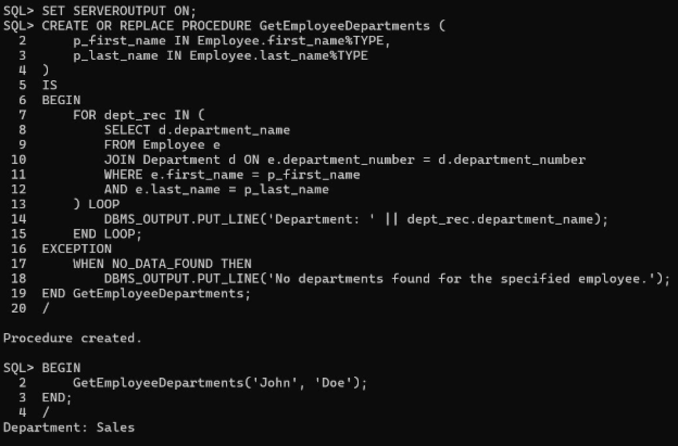

2.

Code:

DECLARE

CURSOR emp_cursor IS

SELECT empno, first_name, mid_name, last_name, ssn_number, birthday, address, sex, salary, supervisor_ssn, department_number

FROM Employee;

v_empno Employee.empno%TYPE; v_first_name Employee.first_name%TYPE; v_mid_name Employee.mid_name%TYPE; v_last_name Employee.last_name%TYPE; v_ssn_number Employee.ssn_number%TYPE; v_birthday Employee.birthday%TYPE; v_address Employee.address%TYPE; v_sex Employee.sex%TYPE; v_salary Employee.salary%TYPE; v_supervisor_ssn Employee.supervisor_ssn%TYPE; v_department_number Employee.department_number%TYPE;

BEGIN

OPEN emp_cursor;

LOOP

FETCH emp_cursor INTO v_empno, v_first_name, v_mid_name, v_last_name, v_ssn_number, v_birthday, v_address, v_sex, v_salary, v_supervisor_ssn, v_department_number;

EXIT WHEN emp_cursor%NOTFOUND;

DBMS_OUTPUT.PUT_LINE('Employee No: ' || v_empno);

DBMS_OUTPUT.PUT_LINE('Name: ' || v_first_name || ' ' || v_mid_name || ' ' || v_last_name);

DBMS_OUTPUT.PUT_LINE('SSN: ' || v_ssn_number);

DBMS_OUTPUT.PUT_LINE('Birthday: ' || TO_CHAR(v_birthday, 'YYYY-MM-DD'));

DBMS_OUTPUT.PUT_LINE('Address: ' || v_address);

DBMS_OUTPUT.PUT_LINE('Sex: ' || v_sex);

DBMS_OUTPUT.PUT_LINE('Salary: $' || v_salary);

DBMS_OUTPUT.PUT_LINE('Supervisor SSN: ' || v_supervisor_ssn); DBMS_OUTPUT.PUT_LINE('Department Number: ' || v_department_number);

DBMS_OUTPUT.PUT_LINE('-----------------------------');

END LOOP;

CLOSE emp_cursor;

END;

/

Output:

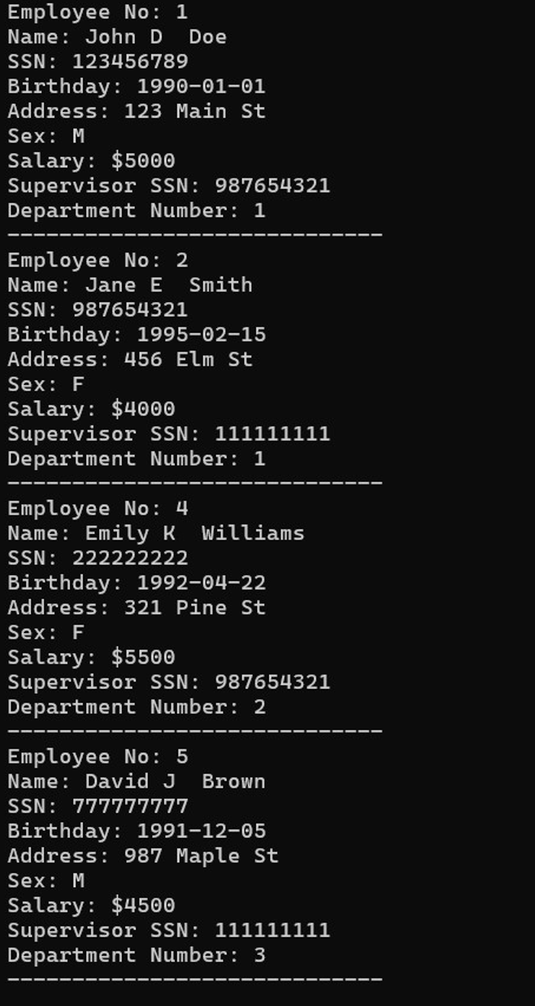

3.

Code:

DECLARE

CURSOR emp_dept_cursor IS

SELECT e.empno, e.first_name, e.mid_name, e.last_name, e.ssn_number, e.birthday, e.address, e.sex, e.salary,

e.supervisor_ssn, e.department_number, d.department_name, d.manager_ssn, d.manager_start_date FROM Employee e

JOIN Department d ON e.department_number = d.department_number;

v_empno Employee.empno%TYPE; v_first_name Employee.first_name%TYPE; v_mid_name Employee.mid_name%TYPE; v_last_name Employee.last_name%TYPE; v_ssn_number Employee.ssn_number%TYPE; v_birthday Employee.birthday%TYPE; v_address Employee.address%TYPE; v_sex Employee.sex%TYPE; v_salary Employee.salary%TYPE; v_supervisor_ssn Employee.supervisor_ssn%TYPE; v_department_number Employee.department_number%TYPE; v_department_name Department.department_name%TYPE; v_manager_ssn Department.manager_ssn%TYPE; v_manager_start_date Department.manager_start_date%TYPE;

BEGIN

OPEN emp_dept_cursor;

LOOP

FETCH emp_dept_cursor INTO v_empno, v_first_name, v_mid_name, v_last_name, v_ssn_number, v_birthday, v_address, v_sex, v_salary, v_supervisor_ssn, v_department_number, v_department_name, v_manager_ssn, v_manager_start_date;

EXIT WHEN emp_dept_cursor%NOTFOUND;

DBMS_OUTPUT.PUT_LINE('Employee No: ' || v_empno);

DBMS_OUTPUT.PUT_LINE('Name: ' || v_first_name || ' ' || v_mid_name || ' ' || v_last_name);

DBMS_OUTPUT.PUT_LINE('SSN: ' || v_ssn_number);

DBMS_OUTPUT.PUT_LINE('Birthday: ' || TO_CHAR(v_birthday, 'YYYY-MM-DD'));

DBMS_OUTPUT.PUT_LINE('Address: ' || v_address);

DBMS_OUTPUT.PUT_LINE('Sex: ' || v_sex);

DBMS_OUTPUT.PUT_LINE('Salary: $' || v_salary);

DBMS_OUTPUT.PUT_LINE('Supervisor SSN: ' || v_supervisor_ssn);

DBMS_OUTPUT.PUT_LINE('Department Number: ' || v_department_number);

DBMS_OUTPUT.PUT_LINE('Department Name: ' || v_department_name);

DBMS_OUTPUT.PUT_LINE('Manager SSN: ' || v_manager_ssn);

DBMS_OUTPUT.PUT_LINE('Manager Start Date: ' || TO_CHAR(v_manager_start_date, 'YYYY-MM-DD'));

DBMS_OUTPUT.PUT_LINE('-----------------------------');

END LOOP;

CLOSE emp_dept_cursor;

END;

/

Output:

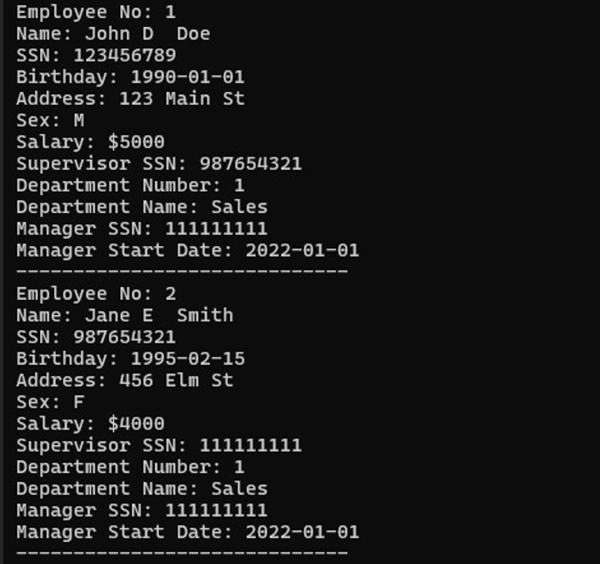 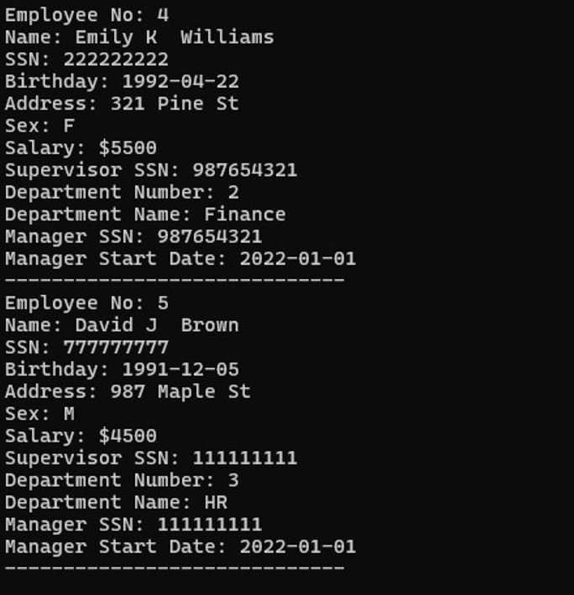

4.

For Creating Tables:

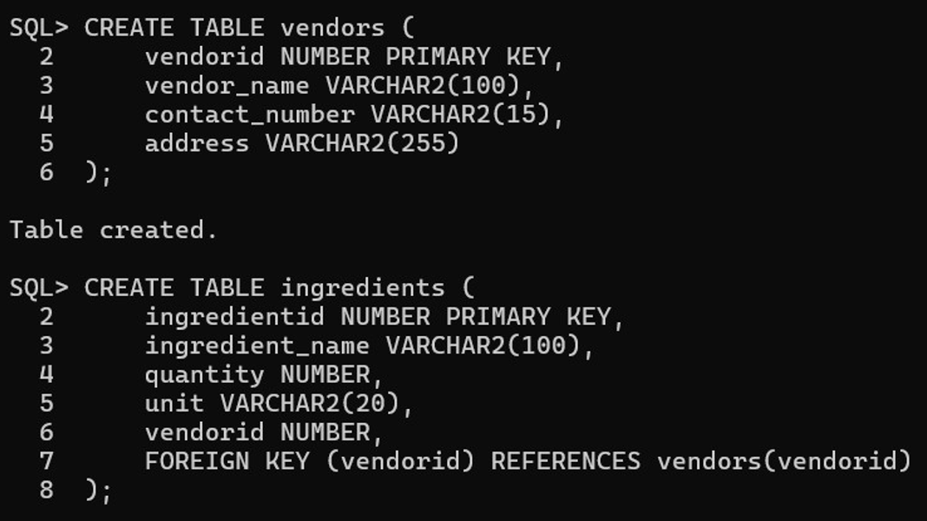

Inserting data:

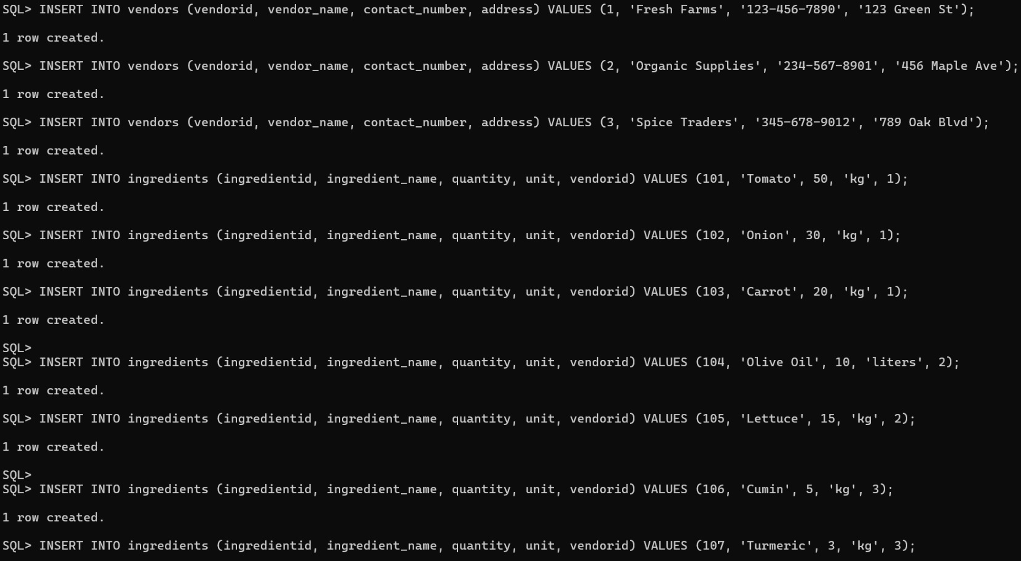

Creating Trigger:

CREATE OR REPLACE TRIGGER update_ingredients_on_vendor_delete

AFTER DELETE ON vendors

FOR EACH ROW

BEGIN

UPDATE ingredients

SET vendorid = NULL

WHERE vendorid = :OLD.vendorid;

END;

/

Before deleting vendorid = 1 contents:

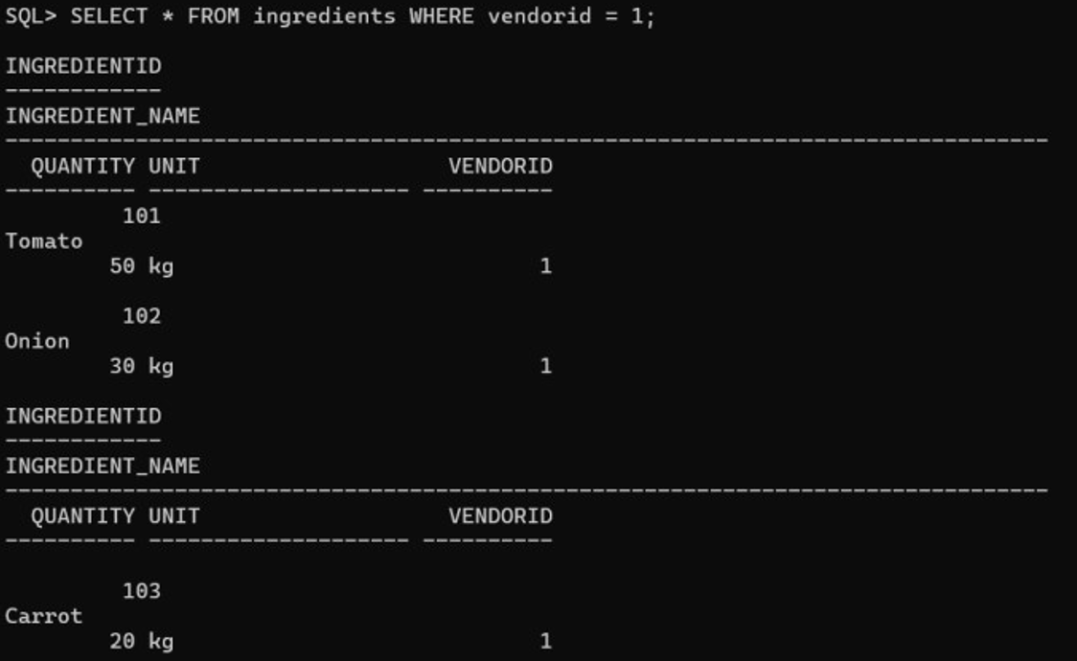

After deleting vendorid = 1 contents:

